Date: Lesson 2

**1.3 Measuring Segments**

**The Ruler Postulate:**

**\* Every point on a line can be paired with a real number, called the of the point.**

**\* How do you find the distance between two points? $\left|coordinate point 1-coordinate point 2\right|$**

**DISTANCE CAN NEVER BE !**

**\* If two segments have the same length, then the segments are .**

**Example 1:**

**Use the number line below to: (A) Find the length of each segment (B) Tell whether the segments are congruent.**



**1. ** and ** 2. ** and 

**Segment Addition Postulate:**

**If three points, *A, B,* and *C are collinear*, and point *B* is between points *A* and *C,* then the distance *AC* is the sum of the distances *AB* and *BC.***

** ***AB* + *BC* = *AC***

**In other words: little piece + little piece = big piece!**

**Example 2:**

**3.**

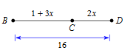

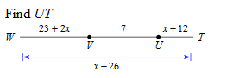**4.**

**5. Points *A, B,*  and *C* are collinear. Point** *B* **is between *A* and *C*. Find the length indicated. (HINT: draw a picture)**



**Midpoint of a Segment:**

**\* The midpoint divides the segment into segments that are equal in length**

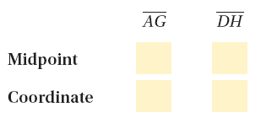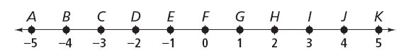

**6.** *W* is the midpoint of *.* If *UW* = *x* + 23, and *WV* = 2*x* + 8, what is *WU?*

Date: 1.3 Practice Problems

1. 2.

3. **Points *A, B,*  and *C* are collinear. Point** *B* **is between *A* and *C*. Find the length indicated. (HINT: draw a picture)**

4. *W* is the midpoint of *.* If *UW* = *x* + 23, and *WV* = 2*x* + 8, what is *UV?*

*Date:*  **1.3 Segment Measures Homework**

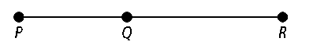**For Exercises 1–3, use the figure at the right.**

**1.** If *PQ* = 7 and *QR* = 10, then *PR* = .

**2.** If *PQ* = 20 and *QR* = 22, then *PR* = .

**3.** If *PR* = 25 and *PQ* = 12, then *QR* = .

**Use the number line below for Exercises 12–16. Tell whether the segments are congruent.**

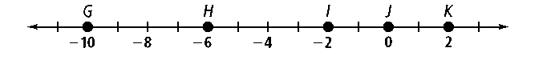

**4.**  and **5.** and **6.** and 

7. Find x. 8. Find x.

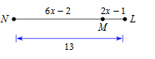

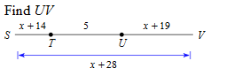9.

10. **Points *A, B,*  and *C* are collinear. Point** *B* **is between *A* and *C*. Find the length indicated. (HINT: draw a picture)**

**

11. *Z* is the midpoint of *.* If *YZ* = *x* + 12, and *ZA* = 6*x* − 13, what is *YA?*