WELCOME to Ms. Jung’s Class!!
Contact me anytime via e-mail at: jung@cranfordschools.org

Dear Students and Families,
Welcome to CP Geometry! I am looking forward to a successful year! I will do my best this year to ensure that each student has a positive learning experience in my classroom while strengthening his/her mathematical skills. With the support of parents/guardians, I know this goal can be achieved. As parents/guardians, you can help by making sure assignments are completed. If you have any concerns about the progress of your child, feel free to contact me. Please take the time to read over all of the information below. When you have finished, please sign and return the contract slip. I know that with your cooperation, we are going to have a great year!
Thanks,
Ms. Jung
CLASSROOM EXPECTATIONS

- You are to arrive to class on time. Lateness without a pass will not be tolerated.
- Enter the room quietly and take your assigned seat.
- Upon entering the classroom, you should copy the homework assignment into your agenda and homework log. Then begin working on the “do now” problem.
- If you are absent, you are still responsible for copying class notes and handing in homework.
- You are to participate actively in class lessons by asking and answering questions.
- You are to exhibit good conduct. You are to RESPECT the property of the teachers, students, and school.
- Value yourself. Be honest and ethical, and practice strong moral values.
- Please do not speak while I/classmate is speaking.
- Raise your hand if you have a question. Calling out will not be tolerated.
- Gum chewing, food, and drink of any kind is not permitted.
- No cell-phones are to be used or seen in class.
- Finally: the bell does not dismiss you, I do.

REWARDS
- ½ off homework pass
- Positive phone call home
- “No homework pass” if you get a 100% on any test or quiz

CONSEQUENCES

You are expected to follow the rules and guidelines set forth in the Student Handbook. You are expected to know and understand the CHS Academic Integrity Procedure.

- Phone call or email home to parent/guardian

- DETENTION –
First Detention: Lunch Detention
Second Detention: Teacher Detention. You are to serve your detention the following day. If you cannot make that date, you are to tell the teacher. If you cannot make the detention due to a doctor’s appointment, you are to bring in a doctor’s note. Athletics and clubs DO NOT get you out of detention. Detention starts promptly at 2:55 and you will be dismissed at 3:20. You will report to room L322 (unless told otherwise) to research a topic assigned by the teacher and write a one page essay.

- If student is persistent with bad behavior then administration will be notified to take further action.

GEOMETRY GRADING POLICY
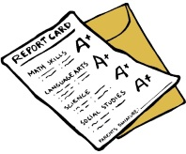
Tests/Projects = 40%
Quizzes = 40%
Homework = 10%
Classwork = 10%

PROJECTS
There will be one project assigned per marking period that relates to a unit we are covering in class. There will be limited time in class to work on the project. Every project will count as one test grade, thus it is important to ask questions and seek extra help if you have any concerns.

HOMEWORK

Homework will be assigned daily. Every homework assignment will be checked for completeness and occasionally may be collected and graded. NO CREDIT will be given for just an answer. Work must be shown to receive credit. Any copied assignment will be considered cheating and will be dealt with very heavily. Homework will not be accepted late unless absent. Students will not be allowed to retrieve homework from lockers. If the homework is not in class, then the student is unprepared, and will receive a 0 for that homework assignment. All assignments are posted on the classroom bulletin board and on my school webpage.

The homework log can be found online at: www.msjungmath.weebly.com

MAKEUP WORK

YOU are responsible for all missed work due to absences. You will be given one day for each day absent to make up any work missed. Missed tests and quizzes will be made up during study hall, before school, or after school. Please see me to schedule.
TEXTBOOK

You can access your e-textbook through your PowerSchool account. Please let me know if you cannot access it or would like to sign-out a book.

EXTRA HELP

I am available for extra help in Room L322: Tuesday, Wednesday, and Thursday AFTER school
Day 1 or Day 3 Activity Period
If you cannot attend any of the times above, then please contact me to schedule another extra help session that meets your needs. Please, make sure to ask if anything is unclear or if you need any help with homework. My door will ALWAYS be open to eager students looking for assistance!

WHAT YOU NEED FOR CLASS:

Your notebook, a THREE-RING BINDER, should contain each of the following in chronological order for easy reference and review:

- DO NOW SECTION: every day date and copy the “do now” and answer the question. (These will be collected periodically and checked for completeness.)
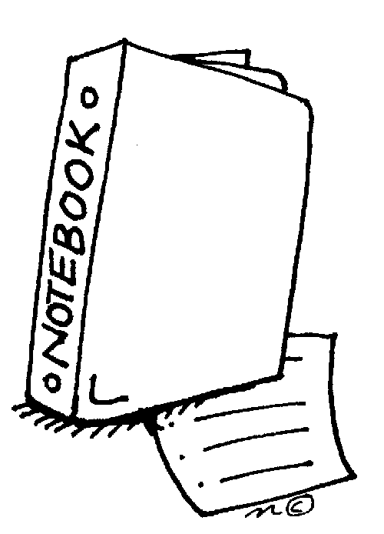
- CLASS NOTES SECTION: notes should be dated

- HOMEWORK SECTION: homework assignments should be labeled with proper heading and homework number

- TEST AND QUIZ SECTION

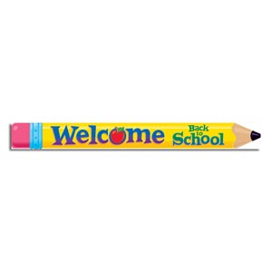
You will be expected to bring your binder, calculator, homework, pencil and pen to class every day. All papers should be kept in your binder until the end of the marking period. Binders will be checked in various ways once or twice a marking period. Every binder check will equal one quiz grade, so it is important to keep a well-organized binder!

Please fill out and return just this section with the student by Monday, September 11th, 2017.
I have hereby read and understand Ms. Jung’s classroom expectations and policies.
Geometry CP Class Color:

Print Student’s Name Student’s Signature

Print Guardian’s Name Guardian’s Signature

