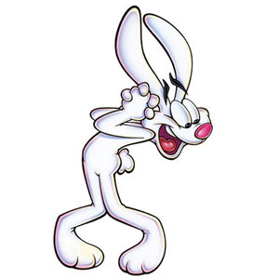
Date: Unit 1 – Lesson 1 Interval and Inequality notation/Domain and Range

What is Interval Notation and Inequality Notation?

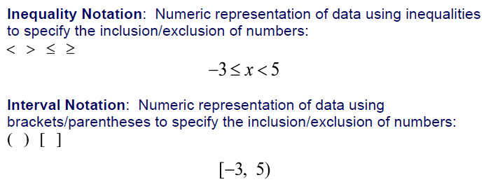

Examples:
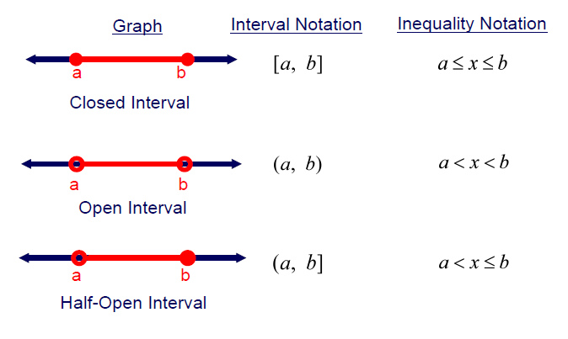
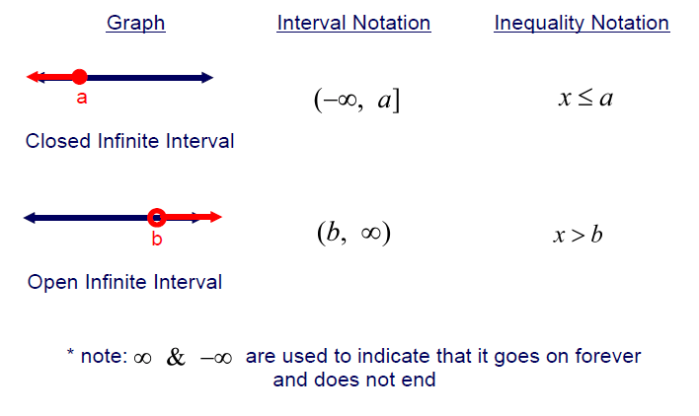

Why do you think parentheses are used in interval notation for
a data set that includes $∞ or-∞$ instead of brackets?

PRACTICE: Give the interval and inequality notation for each graph.

Inequality Notation: Interval Notation:

Inequality Notation: Interval Notation:

Inequality Notation: Interval Notation:

Inequality Notation: Interval Notation:

Inequality Notation: Interval Notation:

Inequality Notation: Interval Notation:

What is a Relation, Domain, and Range?

- A relation is a set of pairs of input and output values.
- The domain of a function or relation is the set of all input values or x-values
- The range of a function or relation is the set of all output values or y-values that were produced using the possible input values.

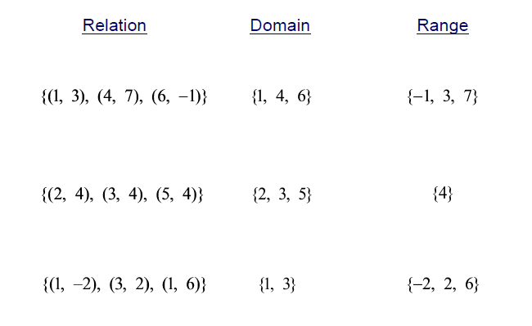
Examples:

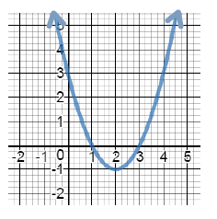
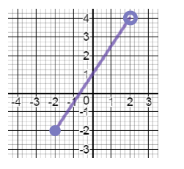
Practice: State the domain and range using interval notation for each graph.
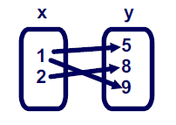
1. 2. 3.

Domain: Domain: Domain:
Range: Range: Range:
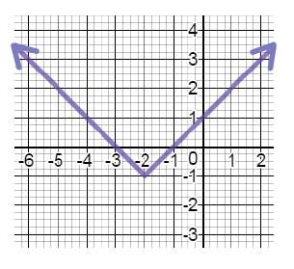
Practice: State the domain and range using inequality notation for each graph.
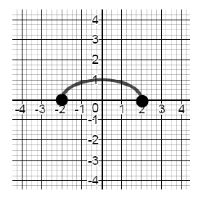
4. 5.

Domain: Domain:
Range: Range:

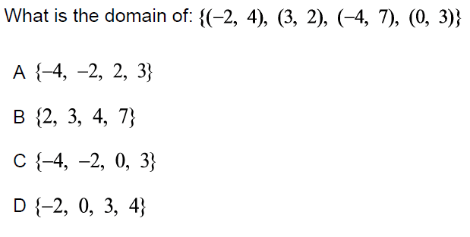
6.

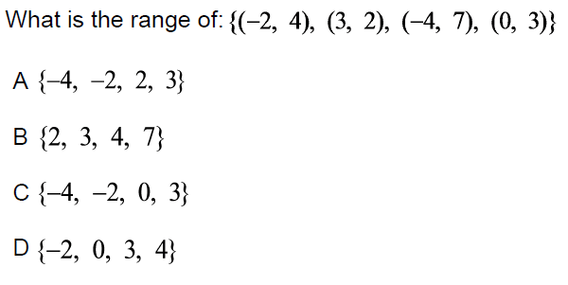

Date: 1.1: Interval and Inequality notation/Domain and Range Homework HW #
Directions: Give the interval and inequality notation for each graph.
1.
Inequality Notation: Interval Notation:

2.
Inequality Notation: Interval Notation:

3.
Inequality Notation: Interval Notation:

4.
Inequality Notation: Interval Notation:

5.
Inequality Notation: Interval Notation:

6.
Inequality Notation: Interval Notation:

Directions: State the domain and range using interval notation for each graph.
7. Domain:
Range:

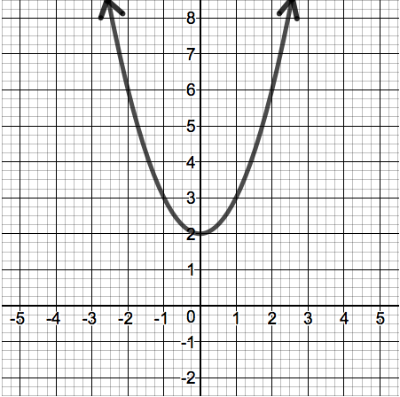
8.
Domain:
Range:

Directions: State the domain and range using inequality notation for each graph.
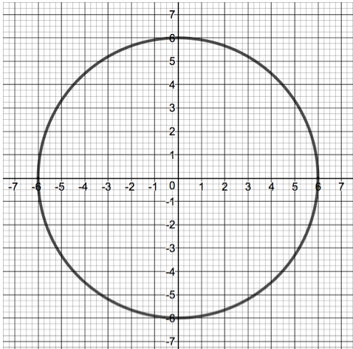
9.
Domain:
Range:

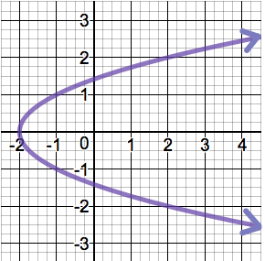
10. Domain:
Range:

