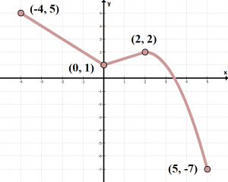
2.5 Generic Functions HW #
Parent function:

Sketch the following:
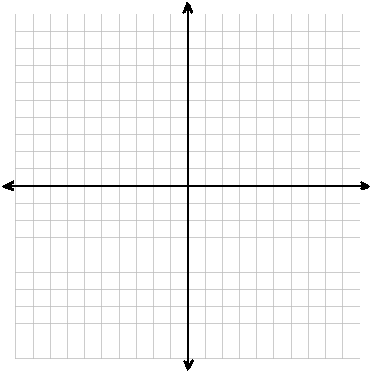
1. $f(x-3)$ 2. $f\left(x\right)- 3$

3. $f(-x)$ 4. $-f(x)$

5. $2f(x)$ 6. $f\left(x+4\right)+ 1$

