Date: HW #
3.4 & 3.5 Slope and Graphing Linear Equations
Directions: Find the slope through the given points.
- $\left(5, -7\right)and (-3, 9)$ 2. $\left(-3, 1\right) and (7, 13)$

Directions: Find the missing coordinate.
3. The slope of a line is $\frac{-2}{3}$ and the line contains the points (-3, 7) and (9, a).
What is the value of a?

4. The slope of a line is 4 and the line contains the points (-1, -8) and (x, 8).
What is the value of x?

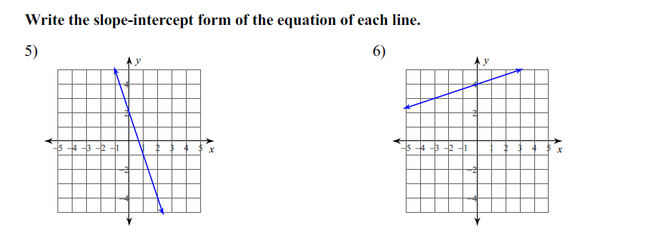

Directions: Graph a line with the given description.

7. $y= -\frac{1}{4}x+2$ 8. $x=4$
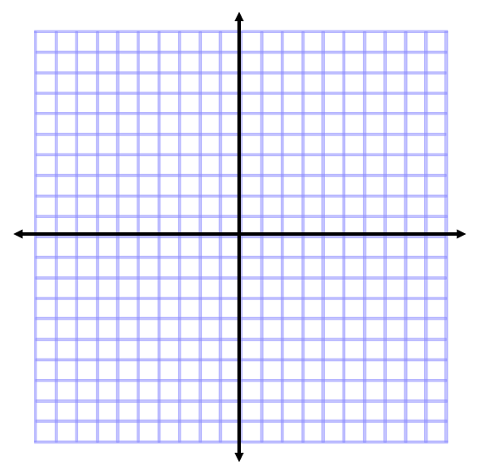

9. $y=3x-5$ 10. Through (1, 1) and parallel to the line
through y = 3x + 2

11. Through (3, 0) and perpendicular to the line 12. Through (1, 3) and perpendicular to the line
through $y=\frac{2}{3}x-5$ through (-1, -1) and (2, 0)

